Parth Babbar

mobile banking services

Introduction:
Mobile banking has transformed financial management in the United States, bringing unparalleled convenience and accessibility. This presentation digs into the current state of mobile banking, including crucial facts, future possibilities, and solutions to existing difficulties. Mobile banking uses dedicated apps on smartphones or tablets, allowing clients to conduct a wide range of financial activities from anywhere.
Key Features:
- Smartphone Deposits: Deposit checks easily by shooting images using the smartphone app, reducing the requirement for actual trips to a bank office.
- Account Management: Monitor balances, check transaction history, and manage numerous accounts from a single mobile platform.
- Cash move: With mobile banking, you may easily move cash between accounts within the same bank or send money to others.
- Bill Payment: Make bill payments easier with the mobile app, assuring prompt settlement of utility bills, credit card payments, and more.
- Alerts and Notifications: Receive real-time alerts and notifications about account activity, which improves security and provides peace of mind.
- ATM Locator: Use the mobile banking app to quickly locate local ATMs and branches, making it easier to access cash and banking services while on the road.
Benefits:
- Accessibility: You can conveniently access financial services while on the go, ensuring that your banking needs are addressed at any time and from any location.
- Real-Time Transactions: Get instant alerts on account activity, providing transparency and prompt financial decisions.
- User-Friendly: Use intuitive interfaces intended for simplicity of use, making banking chores simple and uncomplicated.
- Enhanced Security: Take use of modern security features such as biometric authentication and secure login choices, which provide strong protection of user data and transactions.
Challenges:
- Security Concerns: Mobile devices are vulnerable to hackers and viruses, posing threats to user data and financial transactions.
- Connectivity Issues: Relying on a consistent internet connection for flawless mobile banking experiences can be difficult, particularly in places with weak connectivity.
- User Experience Variability: The quality of user experience differs greatly amongst banking applications, affecting consumer happiness and usability.
Solutions:
- Increased Security: To reduce cyber risks and secure user information, use strong security measures such as encryption, biometric authentication, and continuous transaction monitoring.
- Improved access Solutions: Create offline capabilities and optimise app performance to lessen dependency on continual internet access, resulting in a more seamless user experience under varying network circumstances.
- Standardized User Interfaces: Create industry standards for intuitive and uniform user interfaces across banking apps, which will improve usability and reduce user dissatisfaction.
Future Trends:
- Integration of Emerging Technologies: Mobile banking will use AI and machine learning to provide personalised financial insights and predictive analytics.
- Improved Customer Experience: Banks intend to improve user interfaces and incorporate tools such as voice banking and augmented reality to help with financial planning.
- Service Expansion: Beyond standard duties, mobile banking will offer sophisticated services such as wealth management and personalised investment advice.
- AI-driven Personalisation: Advancements in artificial intelligence will allow banks to provide highly specialised banking experiences, ranging from customised product offers to personalised financial advice
- Mobile Wallet Integration: Mobile banking apps will work seamlessly with mobile wallets, allowing for more efficient payments and collaborations with retailers and service providers.
- Blockchain Revolution: Blockchain technology will revolutionise mobile banking by enabling safe, transparent, and efficient transaction processing.
Banking Providers:
- Traditional Banks: Major institutions such as Bank of America, Wells Fargo, JPMorgan Chase, Citibank, and United States Bank have powerful mobile banking apps.
- Online Banks: Examples of online and mobile banking providers are Ally Bank, Capital One 360, and Discover Bank.
- Credit Unions: Navy Federal Credit Union and PenFed provide mobile banking to its members.
- Fintech Companies: PayPal, Square (Cash App), and Venmo provide mobile banking through their applications.
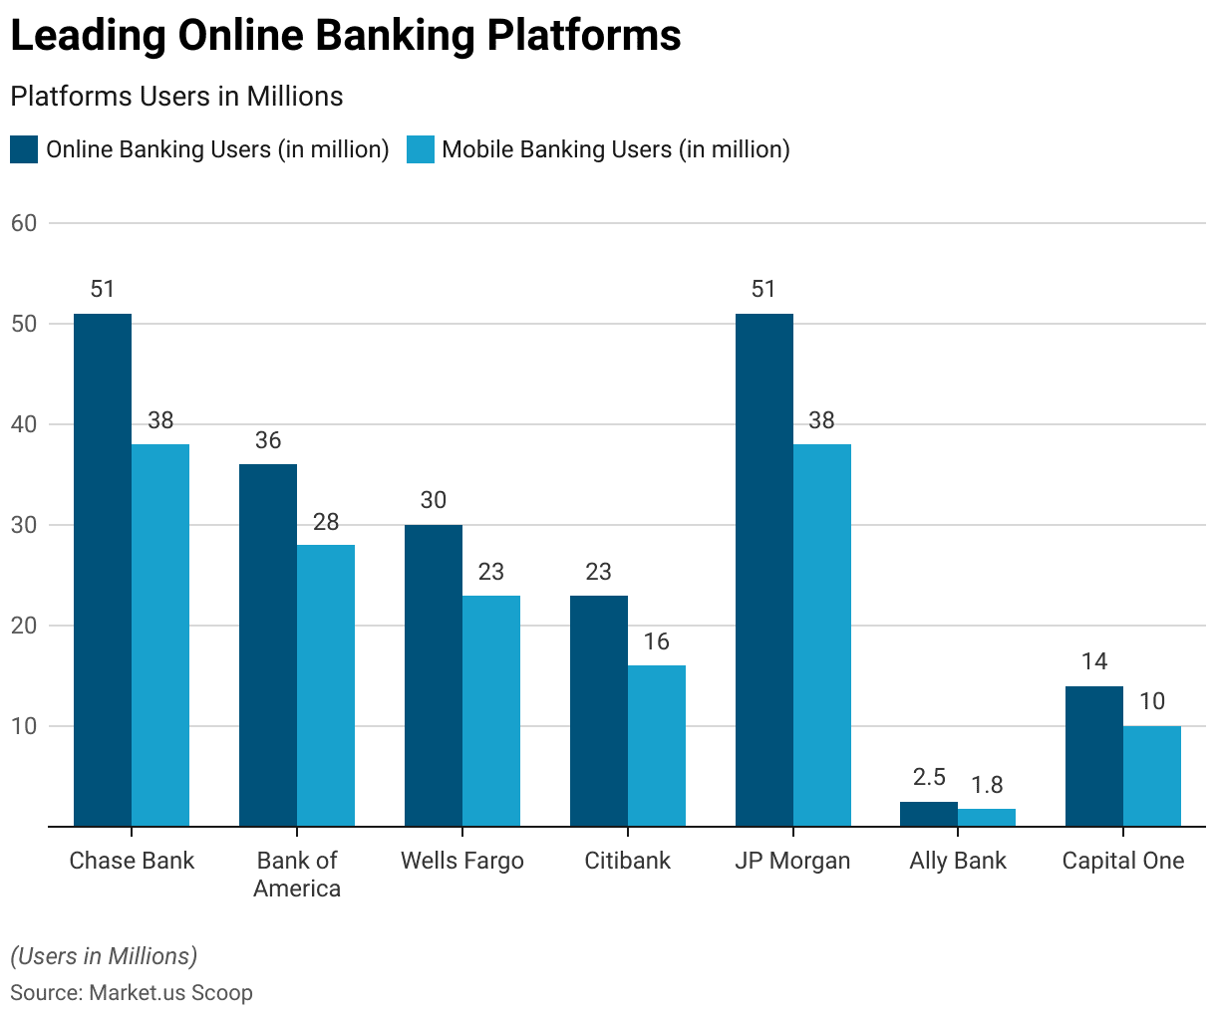
Statistics:
- As of 2023, roughly 72% of US adults utilise mobile banking on a regular basis.
- The highest adoption rates are among millennials and Generation Z, with more than 85% utilising mobile banking apps.
- The number of mobile banking customers is expected to reach 217 million by 2025.
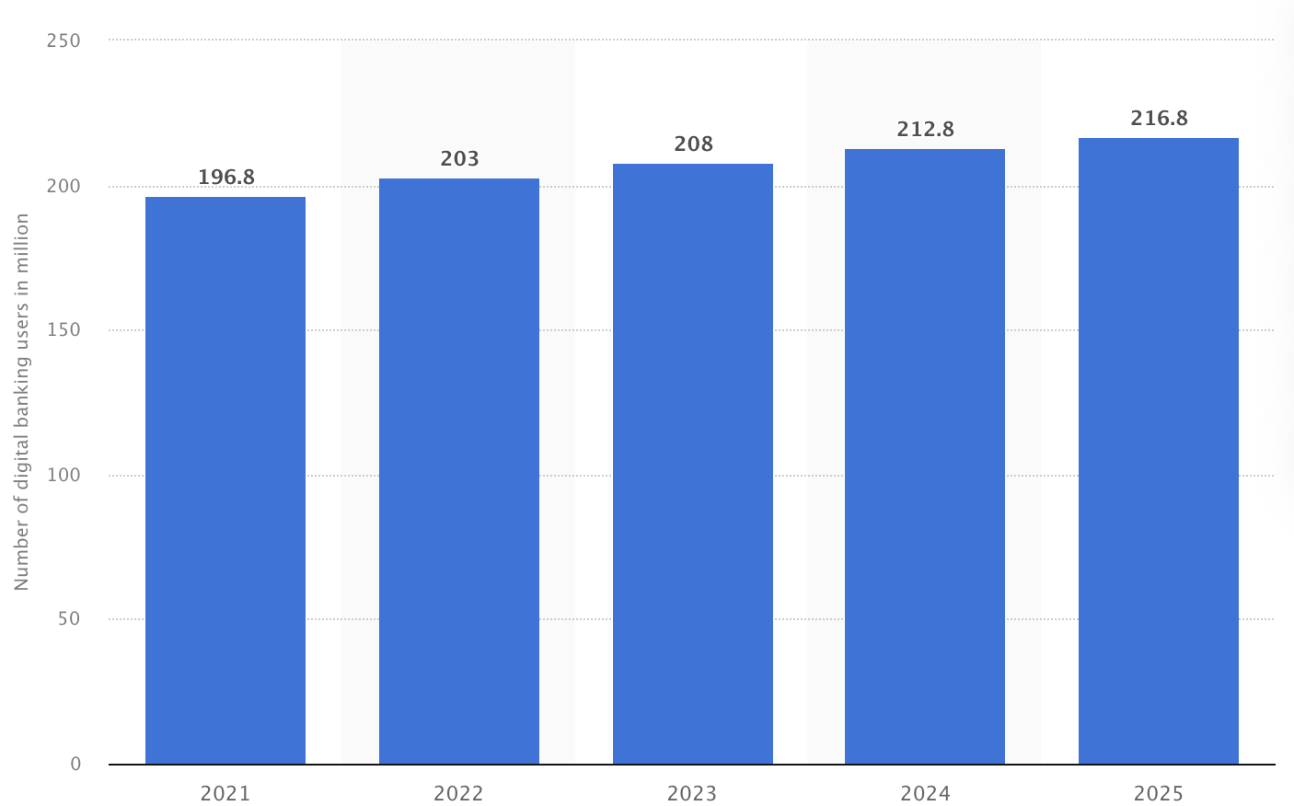
- Losses from mobile banking fraud are expected to total $1.8 billion by 2023.
Conclusion:
Mobile banking services in the United States have altered the way people handle their finances, providing unparalleled ease and accessibility. As technology advances, mobile banking is positioned to expand its capabilities, giving customers with more personalised and secure financial transactions.

